**Hands-On Lab/Demo Script**

**Java Development on Linux with Visual Studio Team Services**

# Exercise 7: Branching, Merging, Pull Requests with Git

Lab version: 1.1.0

Last updated: 3/7/2016



In this exercise, we will see how we can create branches for Git repositories, create pull requests and also configure continuous integrations

## Setting up continuous integration

Having seen how to run a build with unit tests and code coverage, let’s change our build definition to a continuous integration build.

1. Go to the **Build** hub and select **Manual Build** the build definition we created earlier
2. Right-select or click on the down arrow before the build definition and select **Clone**

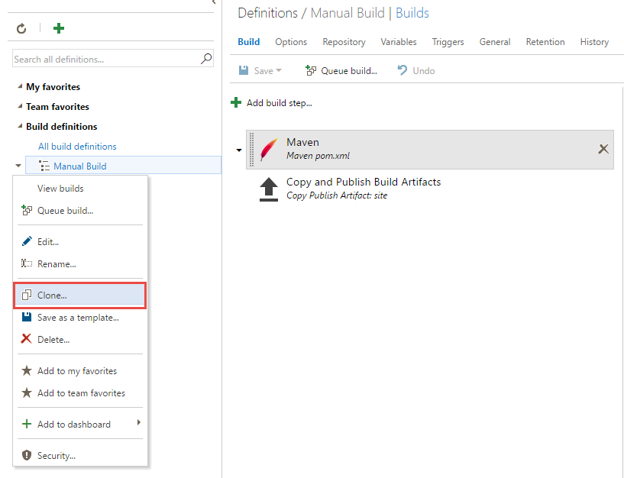

1. Select the cloned build definition and select **Triggers**. Check the **Continuous Integration (CI)** check box. That’s it! – we have changed our build to trigger everytime there is a change pushed to the code repository.

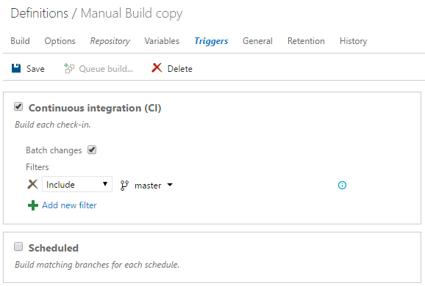

1. Click Save to save the build definition. You may want to provide a different name to the build – say **Myshuttle.CI**

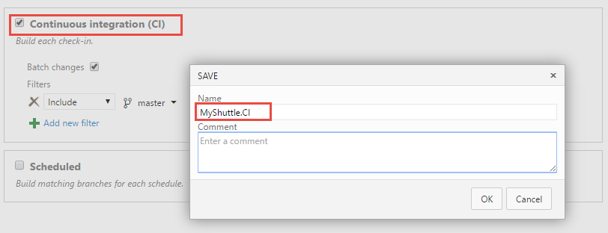

Before we test this build run, let’s see how to isolate our code changes with branching and collaborate on the changes with pull requests.

## Creating a new branch

There are multiple entry points to creating branches in VSTS and TFS – from the work item editor, boards, or from the code hub. Here we will try branching from the work item editor.

1. In your VSTS account, open the work item **Site Fit & Finish.** Click the **Actions (…)** menu and select **New Branch**

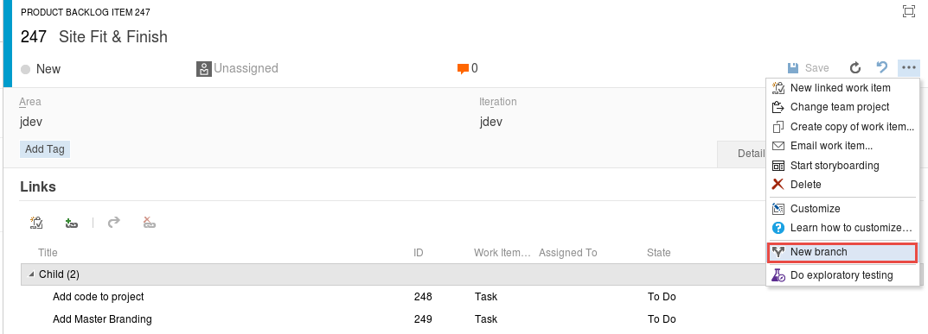

1. In the **New Branch** dialog, enter **addmasterbranding**  for the branch name and select the **Add Master Branding** task from the **Work items to link**  drop-down

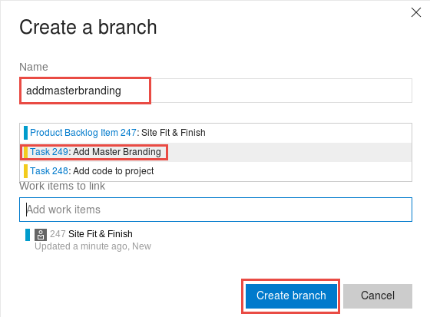

1. Return back to Eclipse. Select **Git**  and open the **Jdev repo**

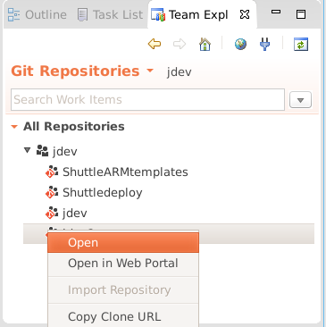

1. This should open the **Git repositories** window. Right-select the **Jdev** repository and choose **Pull** to pull the changes from the server

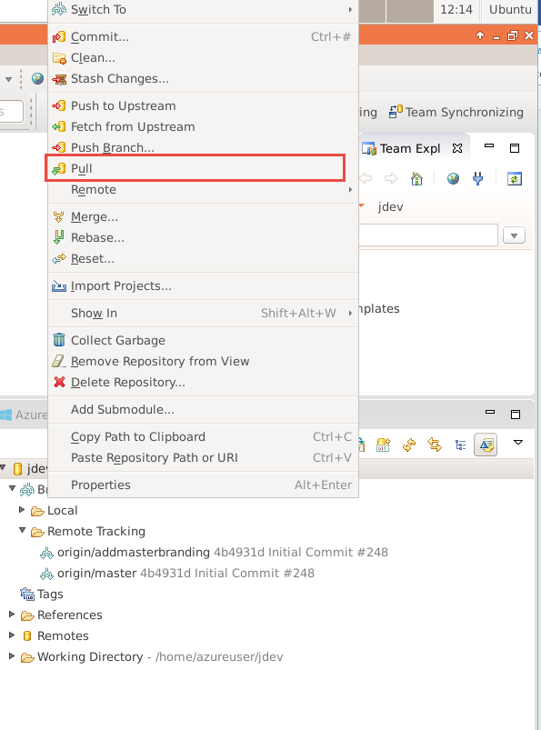

1. You will notice the branch we just created listed under **Branches | Remote Tracking**
2. Right-click the **origin/addmasterbranding** branch and select **Checkout**

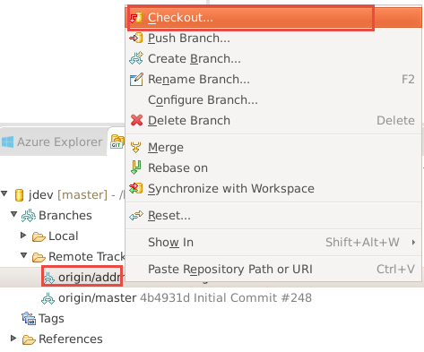

1. When you checkout, you will prompted to create a new local branch. Select **Checkout as New Local Branch**

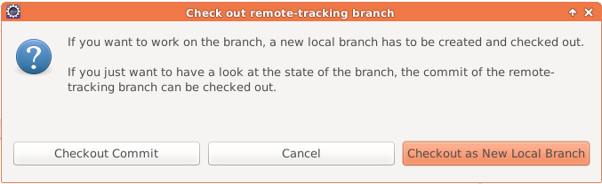

1. You will now notice the project in the project explorer tagged with the branch name.

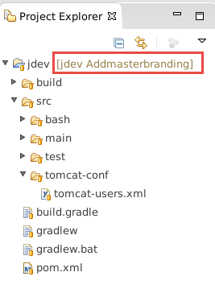

1. Right-click on the **jdev/src/main/webapp** project node and select **Import**.

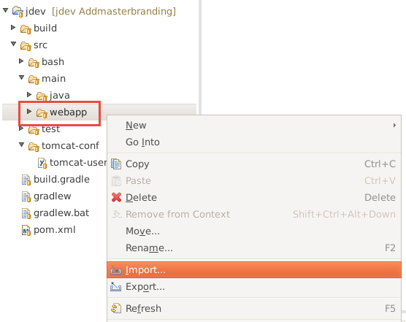

1. Select **File System** under **General** and click **Next**.

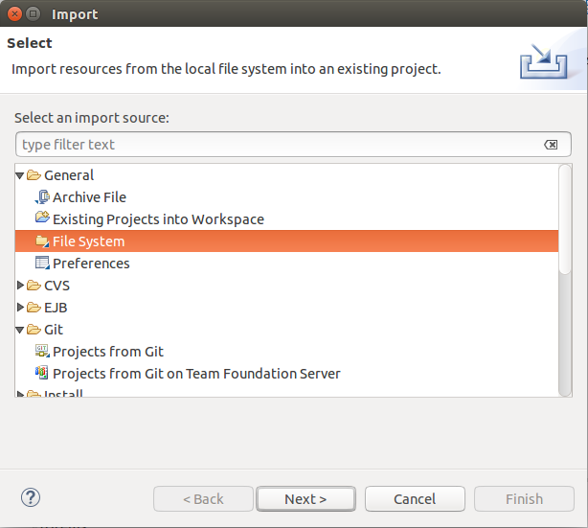

1. Click the **Browse** button. Access your home folder and open the **myshuttle.extras** folder and then the **webapp** folder and click OK. In this folder you’ll find CSS, images, and updated JSP pages to give you the previous displayed images.
2. Select the **webapp** folder and click **Finish.** You will be warned about overwrite to the JSP files. You can ignore the warnings and select to overwrite.

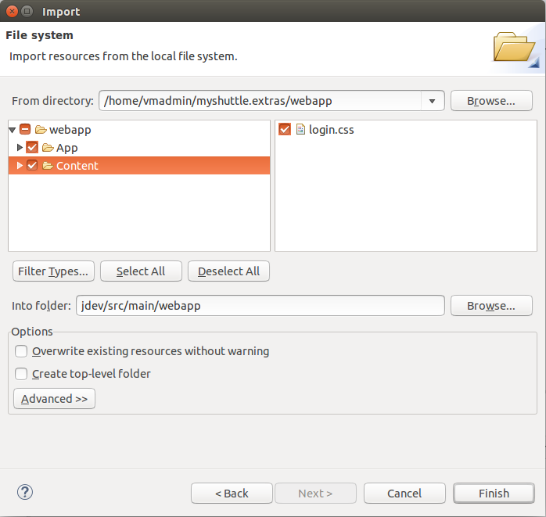

1. Now, right-click on the **jdev** root and select **Team | Commit**. Enter a comment and select **Commit and** Push. This will commit the changes to the ***addmasterbranding*** branch
2. Now return back to the browser and check the **Code** hub if the commits have been successful

## Using pull requests for code review

Pull request is a great way for developers to get team review and collaborate on code changes. When a developer changes a code in a topic branch, he or she can create a pull request to get feedback from the team before merging the code into the master branch. It can also be enforced through branch policies. Anyone participating in the pull request can see the code changed in the branch, leave comments, and give an approval if they're satisfied with the changes.

1. Select the branch ***addmasterbranding*** branch and click on **Pull Request**

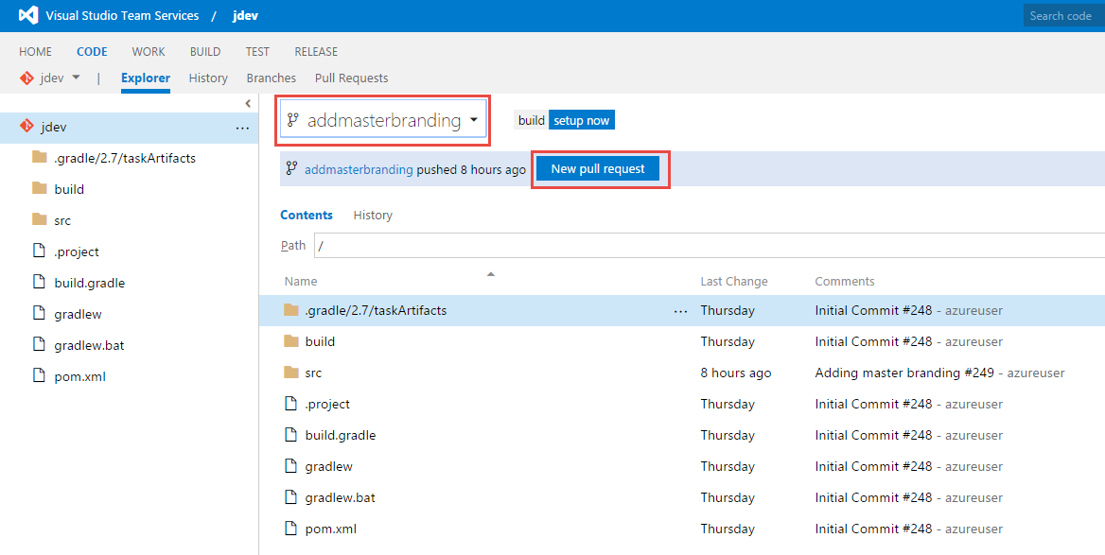

1. This should take you to the Pull Request tab. You can specify the name, description and the reviewers for the pull request. Reviewers can be either individuals or groups  
   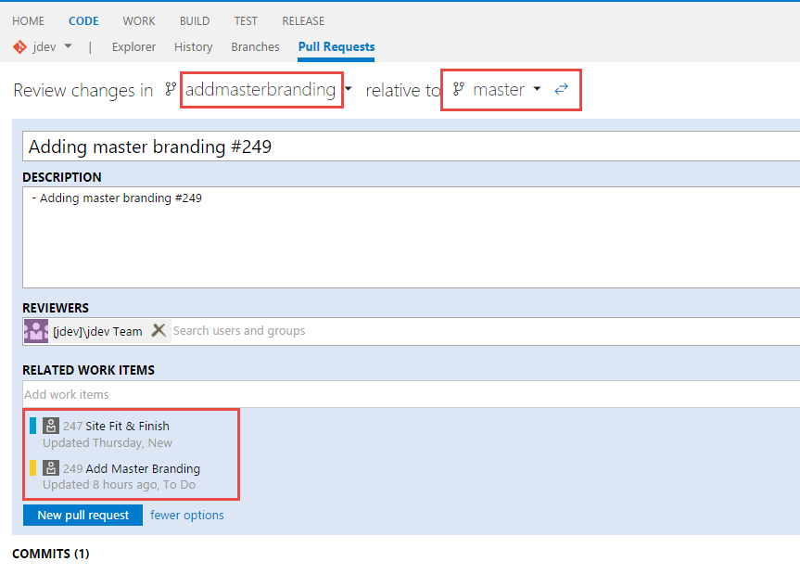

Pull requests will automatically link in work items when a commits in the branch or the entire branch are linked to a work item. You can also manually link work items into the pull request in the **Related Work Items** field when you finish creating the pull request. Typing in a number or work item title text into the work item field will search the work items and return a list that you can quickly pick from to add to the pull request. You can add any number of work items to a pull request in this way.

1. Select **New pull request** to create it.
2. The left navigation panel shows by default the files changed in the pull request along with the comments reviewers have associated with those file changes.
3. Select the **Files** link to show all of the file changes that has been made. You will notice how many files were changed (added/changed/removed) from the top summary tab just below the Files link

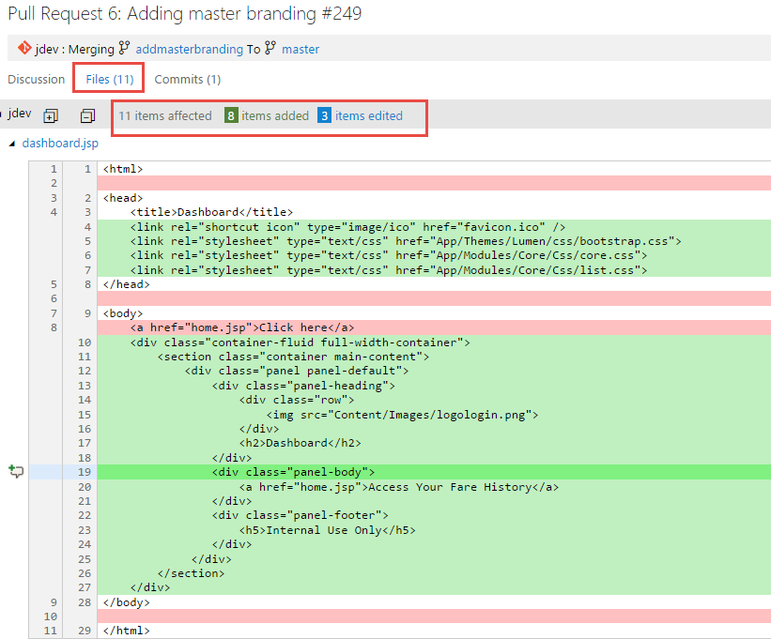

1. You can add comments to the pull request as both author and as a reviewer of the pull request. Comments can be associated with a specific code change or at a general discussion level of the pull request. You can reply to comments and mention others using *@username* or discuss work items using *#workitem* in your remarks.

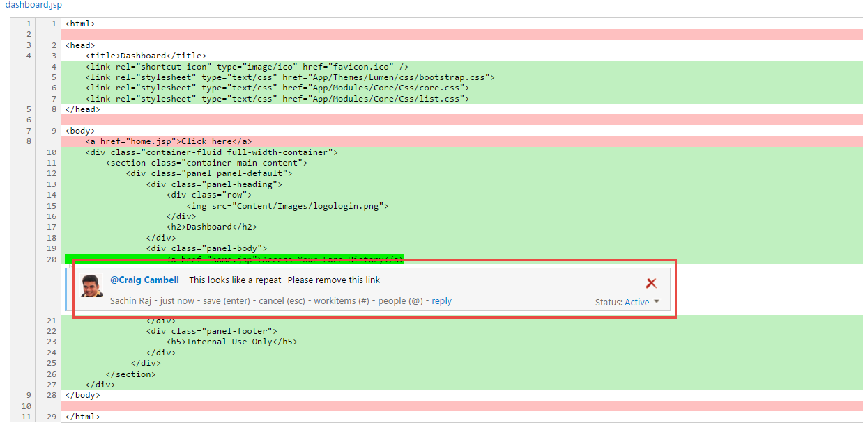

You can mark comments that are made in response to a reviewer feedback as:

* ***Active***: Comment is still under review or active discussion.
* ***Resolved***: The issue brought up in this comment has been addressed.
* ***Won't Fix***: The suggestion in the comment is noted and is actionable, but no changes will be made in this pull request.
* ***Closed***: The remark is no longer a pending action item for the pull request. Usually closed comments are for items that turned out to not have any actions after the finishing the discussion

1. When the pull request owner and the reviewers are satisfied that the pull request is ready to merge, you can do it from the web browser by clicking on the **Complete pull request** button.

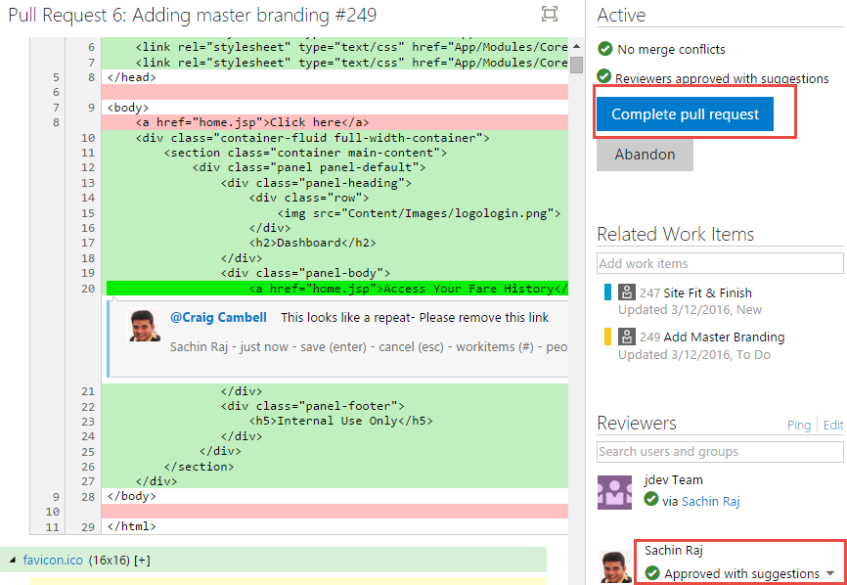

Completing the pull request will merge the changes in the topic branch into the main branch. If you have no further use for the topic branch, you can choose to delete it when you complete the pull request. Deleting the branch is safe because all of its changes are now included in the main branch.

You can also abandon pull requests if the development in the topic branch needs more work before reviewing again. The abandoned pull request will still be viewable in the web interface and linked in from any associated work items. You can reactivate the pull request at any time using the Reactivate button in the pull request.

To give feedback please write to [devopsdemos@microsoft.com](mailto:devopsdemos@microsoft.com)

Copyright © 2016 by Microsoft Corporation. All rights reserved.